**MyMaths Guidance**

At the first screen, insert the school username and password.

School username: leverstock

School password: grid

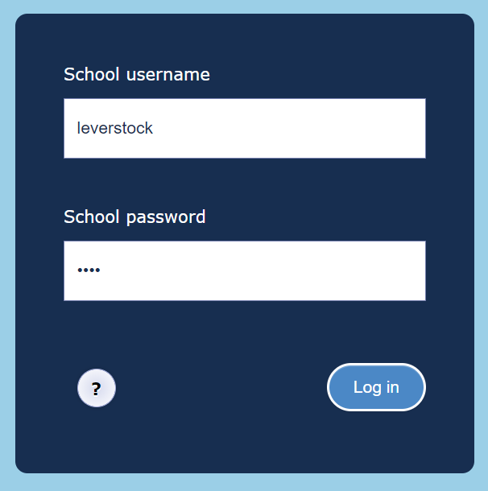

At this point, please enter your portal username and password, which are on the sheet you were given by your teacher.

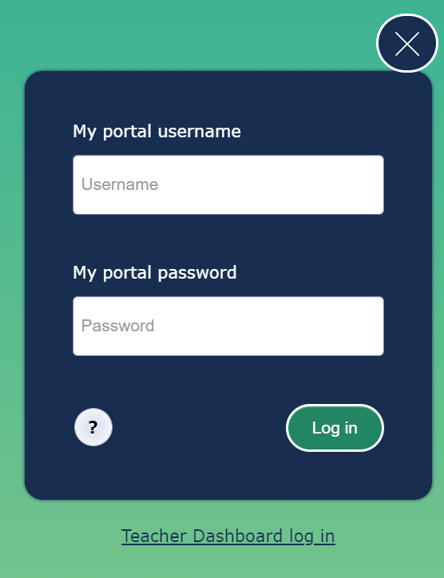

Once you have logged in, you will see the task/s that have been set for you to complete. You can also access various maths games and other resources. Click on the piece of homework you have been given.

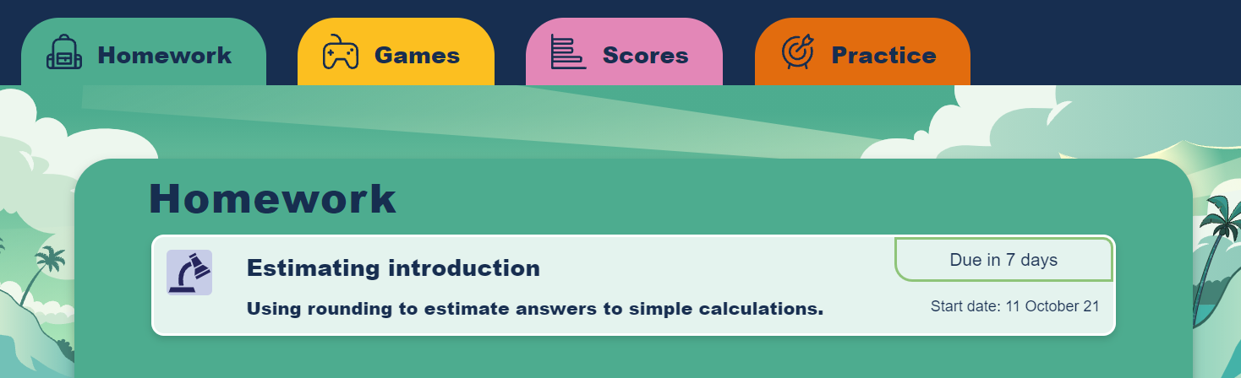

You can go straight into ‘start homework’, or if you are unsure you can go to the lesson on the side, which will give you more guidance.

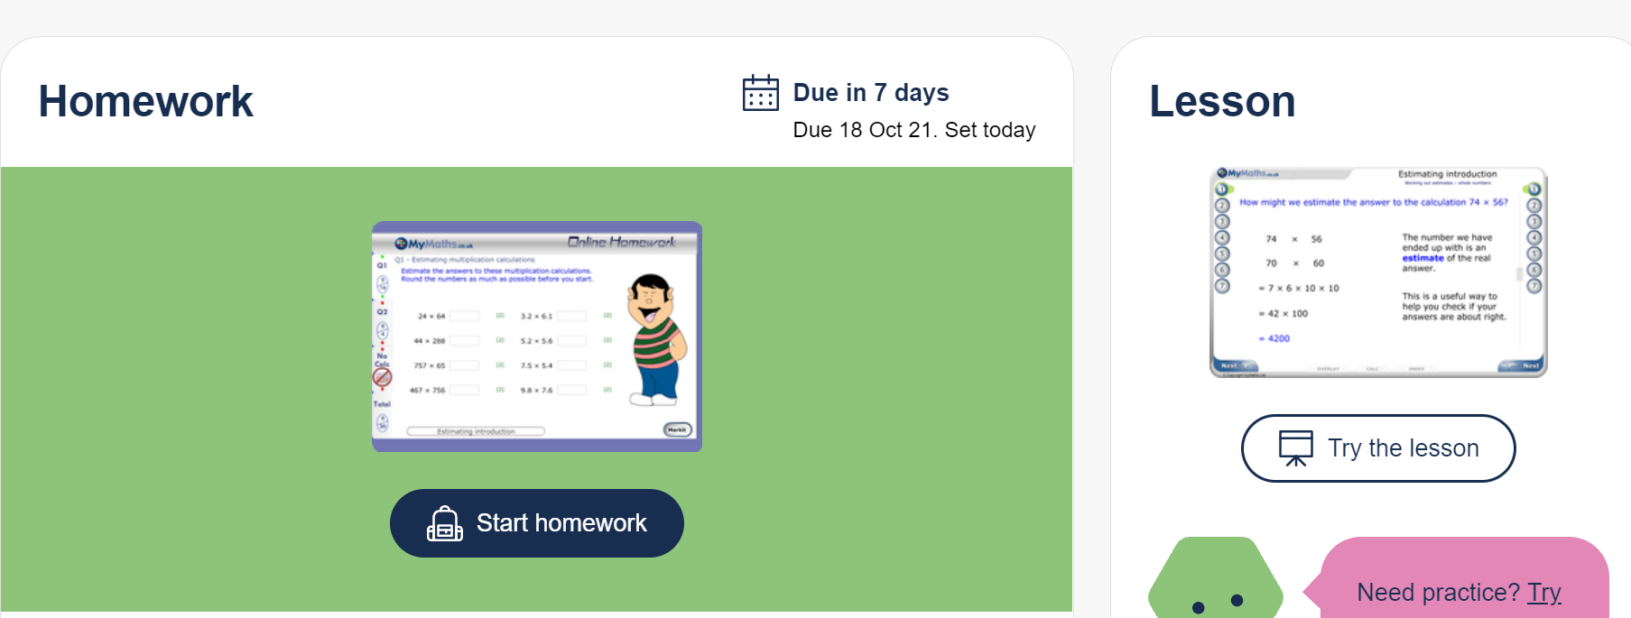

Once you have completed the activity, you MUST click on the ‘mark it’ button at the bottom of the screen. This will show you what you got correct or incorrect. If you have found it tricky you may want to have another go, looking at the lesson first if you have not already done so.