**What can I do to support the Zones of Regulation at home?**

Identify your own feelings using Zones language in front of your child (e.g. “I’m feeling frustrated because….. , I am in the Yellow Zone.”)

* Talk about which tool you will use to be in the appropriate Zone (e.g. “I’m going to go for a walk as I need to get to the Green Zone.”)
* Provide positive reinforcement when your child is in the Green Zone and if they make efforts to stay in the Green Zone. Eg. “I can see you are working really hard to stay in the Green Zone by…”
* Label which Zones your child is in throughout the day (e.g. “You look sleepy, I wonder if you are in the Blue Zone?”)
* Teach your child which Zone tools they can use (e.g. “It’s time for bed, let’s read a book together in the rocking chair to get to the Blue Zone.”)
* Post and reference the Zones visuals and tools in your home (Zone check in stations and toolboxes for the family!) Make portable Zones cards (see editable document on website).
* Play “Feelings Charades”

Take turns choosing emotions from a stack of cards or papers and act it out using only face and body clues. Guess each other’s emotion, discuss which Zone it’s in and why. (Added challenge: Name a tool you could use when feeling that emotion).

* Play “Name that feeling”
* People watch and guess the feelings/zones of others.
* 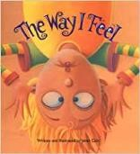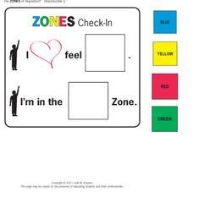Name the feelings of characters while watching a movie (and point out any strategies they use).
* Read ‘The Way I Feel’ by Janan Cain.

* Play “Zones Uno” (can be purchased online).

* 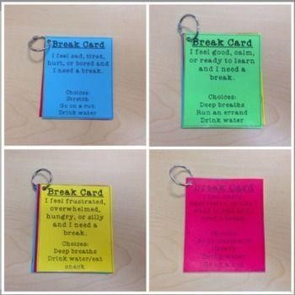Learn the song! <https://www.youtube.com/watch?v=Vnl3GeTkMa4>

