<https://www.bakerross.co.uk/craft-ideas/kids/cardboard-tube-raf-spitfire-plane/>

**How to Make**

**Step 1**

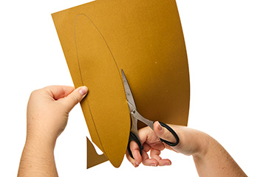

Firstly, using the template, draw and cut out the shapes from card.

**Step 2**

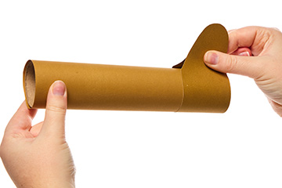

Wrap the cardboard tube in gold paper. Then wrap the rudder template around the back of the plane, with the stabilisers on top.

**Step 3**

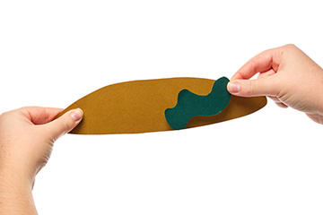

Cut out camouflage shapes from green paper and stick them to the cardboard tube and wings.

**Step 4**

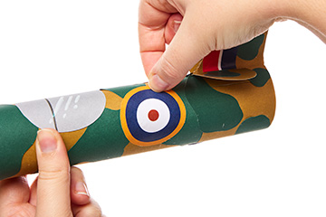

Stick the RAF symbols and window (bubble canopy) onto the plane and wings.

**Step 5**

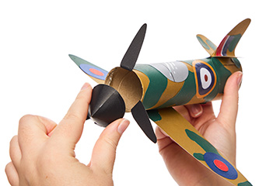

To finish, make a small, black cone using the template provided. Then, stick the black cone and propellers onto the front of the Cardboard Tube RAF Spitfire Plane.